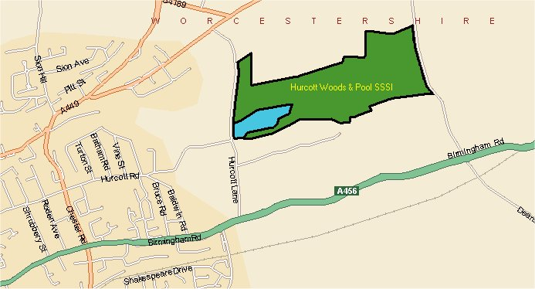
HURCOTT POOLS AND WOOD

© Crown copyright. All rights reserved 100018317 2006
Hurcott is a Beautiful local nature reserve which incorporates the largest area of SSSI wet woodland in the county. It is situated just west of Kidderminster, National Grid Reference SO 857 780.
The reserve is 50 hectares in size, and within this area are various types of woodland, ranging from Hickory and Larch planted woodlands through to beautiful Chestnut groves. There are also a series of pools on site, the largest being situated alongside the main pathway into the site. The pool is a spectacular site and is a haven for bird life.
Management Objectives:
To survey and improve the quality of the wet woodland.
Management aims:
To manage the surrounding mixed woodland as an amenity for people to enjoy informal recreation.

