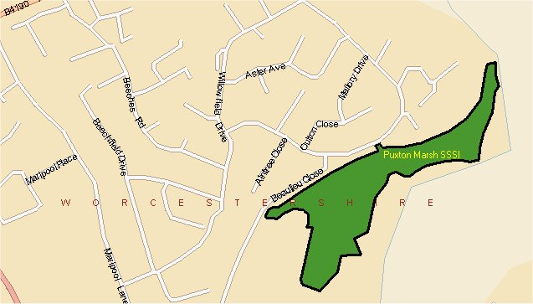
Puxton Marsh

© Crown copyright. All rights reserved 100018317 2006
Puxton Marsh is a 6-hectare Site of Special Scientific Interest situated ½ km to the north of Kidderminster Town Centre. It is one of the largest and most important areas of marshland remaining in the country, and is a remnant of a more extensive marshland once present in the Stour Valley.The site comprises a large area of unimproved marshy grassland with associated damp woodland and open water with extensive area of high quality marshland with a flora that includes Southern Marsh Orchids and a fauna of water rail, snipe and slow worms.
Management Objectives:
To maintain and improve the marshland habitat and to link the site with other areas of marshland in the Stour Valley.
Management aims:
To maintain and enhance existing marshland including grazing of marshy grassland link to GAP to improve floristic diversity.
To manage the wet woodland; increase the area of marshland improve provisions for public access.

